Introduction about myself

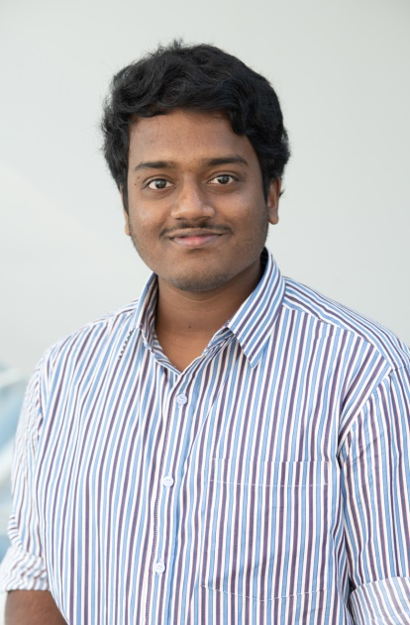

Greetings, Professor. My name is Venkata Sripadh Kausthub Adidam and I am a Computer Science graduate student studying 2nd Semester in State University of New York at New Paltz. I have done by Bachelor of Engineering in Computer Science in India from 2014 to 2018.

I worked as a Network Analyst from January, 2019 to July, 2019 in HCL Technologies in India. I am interested towards programming, which led me to take Masters in Computer Science. I have taken courses like Programming & Data Structures, Computer Systems and Database design in my 1st Semester which enhanced my coding skills and also gave me an edge of database and SQL queries.

Since my bachelors, I was interested in Web Programming and I am excited to use this opportunity to become good at various technologies that will be provided in this curriculum. I have created web pages using HTML and Java in my bachelors. Now, I would like to improve myself by learning more technologies which will be covered in this course so that at the end of the day, I will be equipped with programming languages like CSS, Java Script and many more.